**Assignment1**

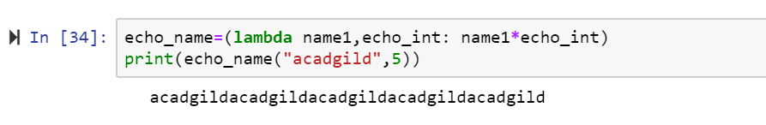

**Assignment2**

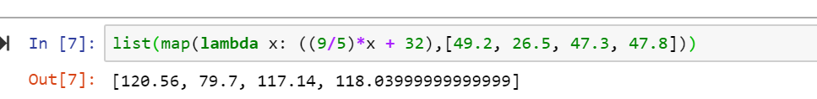

**Assignment3**

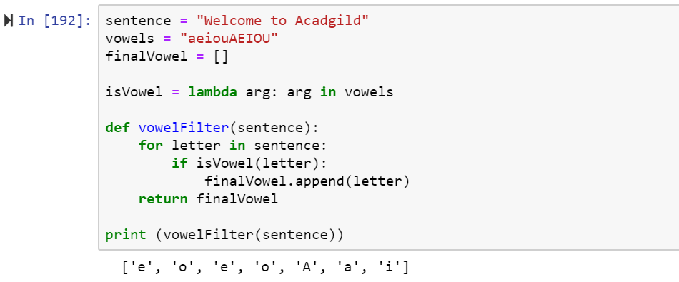

**Assignment4**

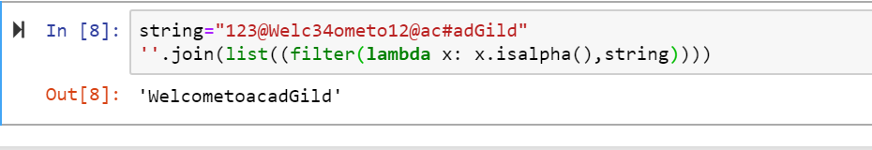

**Assignment5**

